SOFTWARE REQUIREMENTS SPECIFICATION

**For**

**JOB PORTAL**

**Prepared by:-**

*K.SOBIGA,M.SUBASRI,*

*N.SANTHOSH*

# Introduction

## Purpose

Certainly! The purpose of a job portal project using JavaScript is to create an online platform that facilitates the connection between job seekers and employers. A job portal application is a software system that implements the functionalities of a job portal, such as creating user profiles, browsing and searching for jobs, uploading resumes, sending applications, and receiving notifications. The main objective of this document is to illustrate the requirements of the project Job Portal Application using JavaFX. The document gives the detailed description of both functional and non-functional requirements proposed by the client.

## Document Conventions

* + - Entire document should be justified.
    - Convention for Main title

Font face: Times New Roman Font style: Bold

Font Size: 14

* + - Convention for Sub title

Font face: Times New Roman Font style: Bold

Font Size: 12

* + - Convention for body

Font face: Times New Roman Font Size: 12

## Scope of Development Project

This development project aims to create a user-friendly job portal using JavaScript technologies. The primary objectives include providing a platform for job seekers to discover and apply for job opportunities and for employers to post and manage job listings. The scope is to develop a user-friendly and interactive job portal application using JavaFX, a software platform for creating and delivering desktop applications. JavaFX provides a rich set of graphics and media APIs, as well as a declarative scripting language called FXML, which allows developers to design user interfaces with less code.

## Definitions, Acronyms and Abbreviations

JAVA -platform independence SQL- Structured query Language ER- Entity Relationship

UML-Unified Modeling Language

IDE- Integrated Development Environment SRS- Software Requirement Specification

## References

* + - Books

 Software Requirements and Specifications: A Lexicon of Practice, Principles and Prejudices (ACM Press) by Michael Jackson

Software Requirements (Microsoft) Second EditionBy Karl E. Wiegers

Software Engineering: A Practitioner’s Approach Fifth Edition By Roger S. Pressman

* + - Websites

[**http://www.slideshare.net/**](http://www.slideshare.net/)

[**http://ebookily.net/doc/srs-library-management-system**](http://ebookily.net/doc/srs-library-management-system)

# Overall Descriptions

## Product Perspective

Job portal project in JavaScript should focus on creating a user-friendly platform where job seekers can easily search for and apply to relevant job opportunities. It includes features like user registration and profiles, job listings, application process, notifications, user dashboard, filtering and sorting options, messaging and communication, and user reviews and ratings. By considering these aspects, you can create a seamless and efficient job portal experience for both employers and job seekers.

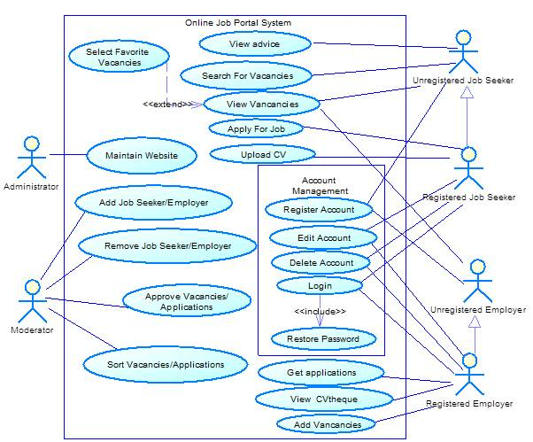

## Product Function

The product function of this project development is that it should primarily focus on connecting job seekers with relevant job opportunities and providing employers with a platform to post and manage job listings. By facilitating user registration, job search and application processes, and efficient communication between job seekers and employers, your job portal will serve as a valuable tool for both parties in the job market. With a user-friendly interface and streamlined functionality, the project will help bridge the gap between job seekers and employers, making the job search process more efficient and effective.

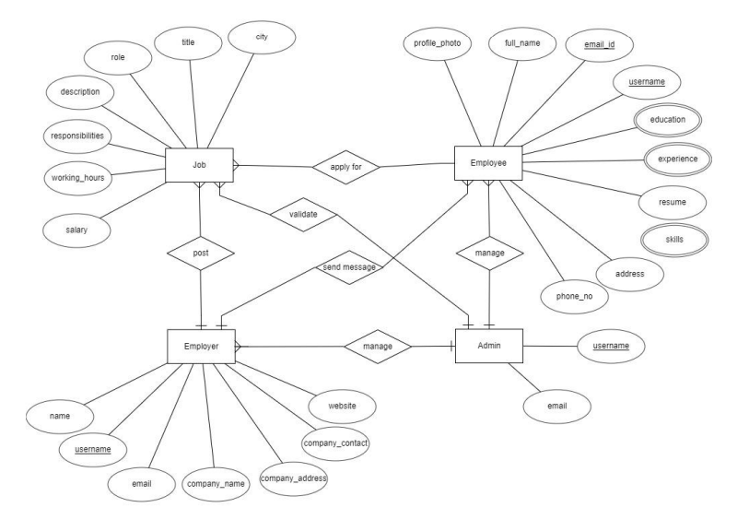

ER-DIAGRAM FOR JOB PORTAL

## User Classes and Characteristics

The User class can have characteristics such as a unique user ID, username, email, password, and profile information like skills, experience, and education. Additionally, it can include methods in the User class to handle tasks like user registration, login, profile management, and job application submission. By implementing the User class with these characteristics and functionalities, we'll be able to provide a personalized and efficient experience for the users of the job portal.

Users will fall into two categories: job seekers and employers.

The Features that are available to Job seekers are :-

● Can search for jobs

● Can apply for jobs by submitting resume

● Track the job application

The Features that are available to Job seekers are :-

● Post the job vacancy

● Review the resume submitted by applicant

● Manage applications.

## Operating Environment

The Job portal Application is a desktop Application that it can run on a variety of platforms and browsers. JavaScript is a versatile language that is supported by most modern web browsers, making it a great choice for web-based projects like yours. To ensure compatibility, we can develop your job portal to be responsive and mobile-friendly, allowing users to access it seamlessly from different devices such as desktops, laptops, tablets, and smartphones. By optimizing your project for various operating environments, we'll be able to reach a wider audience and provide a smooth user experience across different devices.

## Assumptions and Dependencies

Assumptions:

1. Users will have access to a stable internet connection to use the job portal.

2. Users will have basic computer literacy skills to navigate and interact with the platform.

3. The job portal will rely on a database to store and retrieve user and job listing information.

4. Users will provide accurate and up-to-date information during the registration and profile creation process.

Dependencies:

1. The job portal project will depend on a reliable web hosting service to ensure the platform is accessible to users.

2. The project may depend on third-party APIs or services for features like job search, email notifications, or user authentication.

3. The project may require integration with payment gateways if you plan to offer premium features or job posting options.

4. The project may require ongoing maintenance and updates to address security vulnerabilities or improve functionality based on user feedback.

These assumptions and dependencies should be considered while planning and developing your job portal project.

## Requirement

* System Configuration - This software package is developed using JavaFX as the front end which is supported by Oracle Corporation.
* Postgresql as the back end to store the database.
* Operating System: Windows 10, Linux, Mac OS Language: Java 11 or higher, JavaFX 11 or higher (front end) Database: Postgresql Hardware Configuration-
* Processor: Intel Core i3 or higher Hard Disk: 80GB or more RAM: 4GB or more.

## Data Requirement

This includes user data like usernames, email address, and profiles. We’ll also need job listing data, such as job titles, descriptions, and company information. Communication data, like messages between users, can facilitate interactions. Collecting analystics data can provide insights into user behaviour. Lastly, security data is crucial for protecting user accounts and ensuring data privacy. Remember to handle data securely and comply with relevant regulations.

# External Interface Requirement

## GUI

The system will provide a graphical interface for users and administrators. It will allow quick report viewing, stock verification, and search based on different criteria.

The interface should be customizable, simple, and follow a standard template.

Login Interface: Users can create accounts and log in. Incorrect login attempts trigger error messages.

Search: Users can search for jobs by entering the job title or keywords.

Categories View: Displays categories of jobs and allows the administrator to manage categories. Administrator’s Control Panel: Allows administrators to manage users, job postings, and application options.

# System Features

● User Authentication and Validation: Members will be authenticated and validated using their unique member ID.

● Account Monitoring by Administrator: The administrator will monitor and update account status. A popup will be shown if a member attempts to exceed the book issuance limit. Members who skip the return date will have fines assigned to their accounts.

● Proper Accountability: Members will not be able to access other members' accounts. Only the administrator will have access to and manage all member accounts

# Other Non-functional Requirements

## Performance Requirement

The system should be,

-Fast response time

- Scalability to handle a large user base

- Efficient search and filtering options

- Reliable application tracking

- Secure data handling

- High availability with minimal downtime

- Mobile responsiveness for seamless use on different devices

- Efficient messaging system for real-time communication

- Prompt notification delivery

- Robust analytics and reporting capabilities

These performance requirements are crucial for creating a successful and user-friendly job portal.

## Safety Requirement

The Safety is of utmost importance in any project to ensure the well-being and security of users. Some key safety requirements include implementing robust security measures to protect user data, providing privacy settings to allow users control over their information, implementing anti-fraud measures to prevent scams, promoting safe practices through user guidelines, ensuring secure communication channels, and complying with data protection regulations. By prioritizing safety, the project can create a secure and trustworthy environment for all users involved.

The database may get crashed at any certain time due to virus or operating system failure. Therefore, it is required to take the database backup so that the database is not lost. Proper UPS/inverter facility should be there in case of power supply failure.

## Security Requirement

One safety requirement for a job portal is to have secure user authentication and data protection measures in place. This includes implementing strong password policies, using encryption to protect sensitive user information, and regularly updating security protocols to prevent unauthorized access. By ensuring the safety of user data, the job portal can build trust and provide a secure platform for job seekers and employers.

## Requirement attributes

● Multiple Admins: There may be multiple admins creating the project, and all of them will have the right to make changes to the system, but the members or other users cannot make changes.

● Open Source: The project should be open source.

● Quality and User-Friendliness: The quality of the database should be maintained in such a way that it is very user-friendly to all the users of the database.

● Easy Installation: The user should be able to easily download and install the system.

## Business Rules

The business rules for a job portal include features such as job posting, job search, application submission, candidate screening, communication between employers and job seekers, user profiles, job alerts, and feedback and ratings. These rules help create an organized and efficient platform for connecting job seekers and employers.

## User Requirement

Users have different requirements when it comes to job portals.

Some common user requirements include an easy-to-use interface for job search and application submission, personalized job recommendations based on their skills and preferences, the ability to save and track job applications, notifications for new job postings, and a secure platform to protect their personal information. Meeting these requirements can enhance the user experience and increase the chances of finding the right job.